Lab-Project 4: Static Acquisition
Course Name: FRS301-Digital Forensics
Student Name: Nguyễn Trần Vinh – SE160258
Instructor Name: Lê Tiến Dũng
Lab Due Date: 3/2/2023

What You Need for This Project
- VMware Workstation
- Any other tools you choose to use

Getting the Evidence File
- Download ProjX2-sparse.zip file (or Lab-Proj.04_sparse.zip from the instructor).
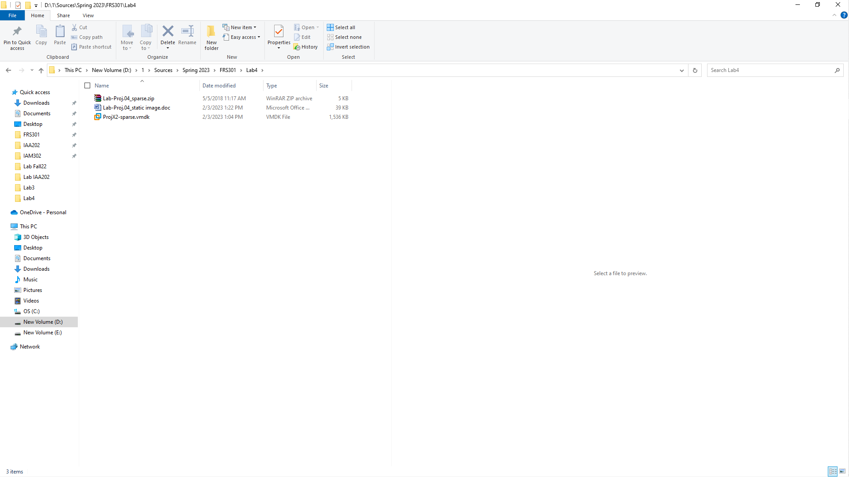
- Calculate the MD5 hash of the file and verify that it matches the value shown to the right on this page.
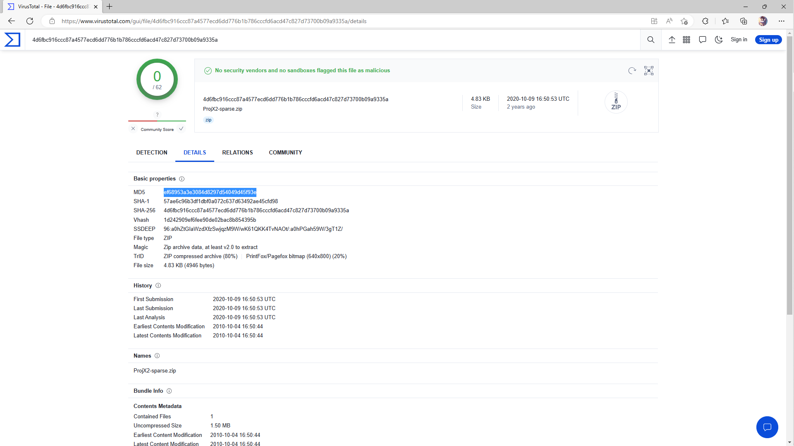
- Unzip the file to extract the virtual hard disk inside.

Imaging the Evidence Drive
- Mount the evidence drive in an appropriate virtual machine.
- Use any technique you like to make a correct forensic image of the drive.
- Calculate the MD5 hash of your forensic image.
. 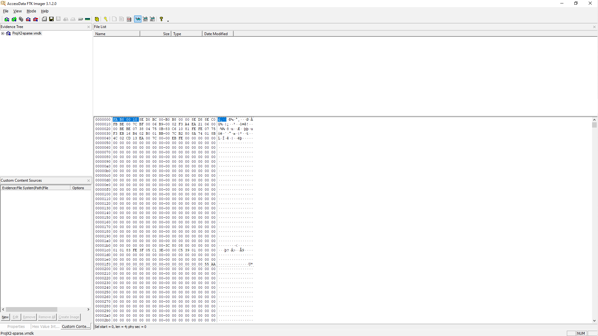

Saving a Screen Image
- Make sure your screen shows the MD5 of the image, from whatever tool you chose to use. 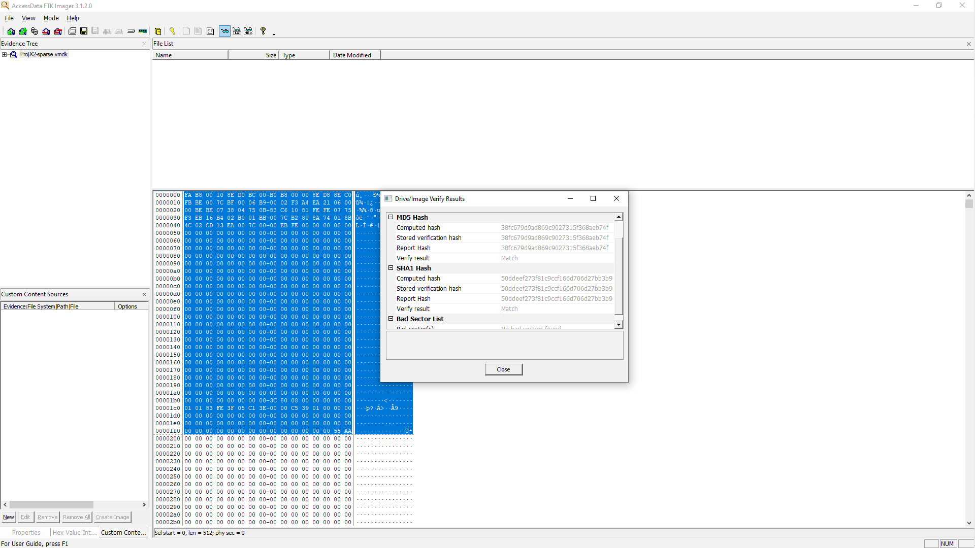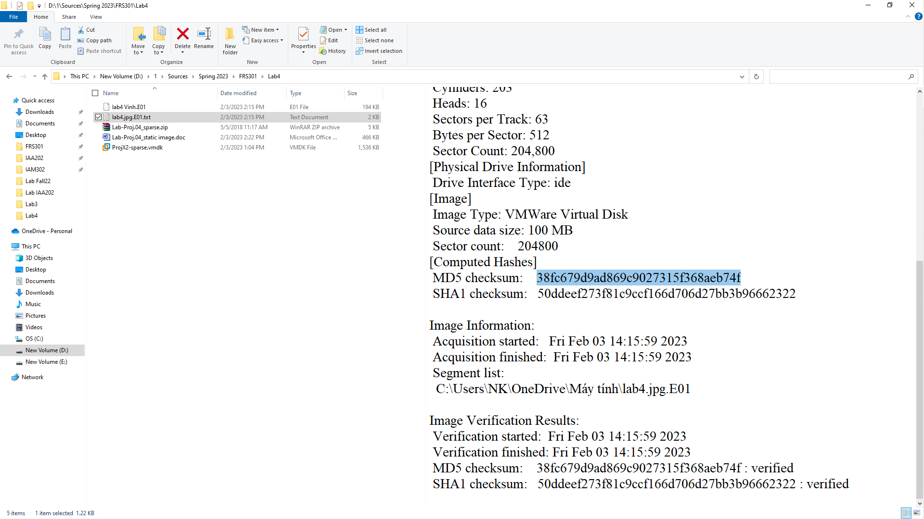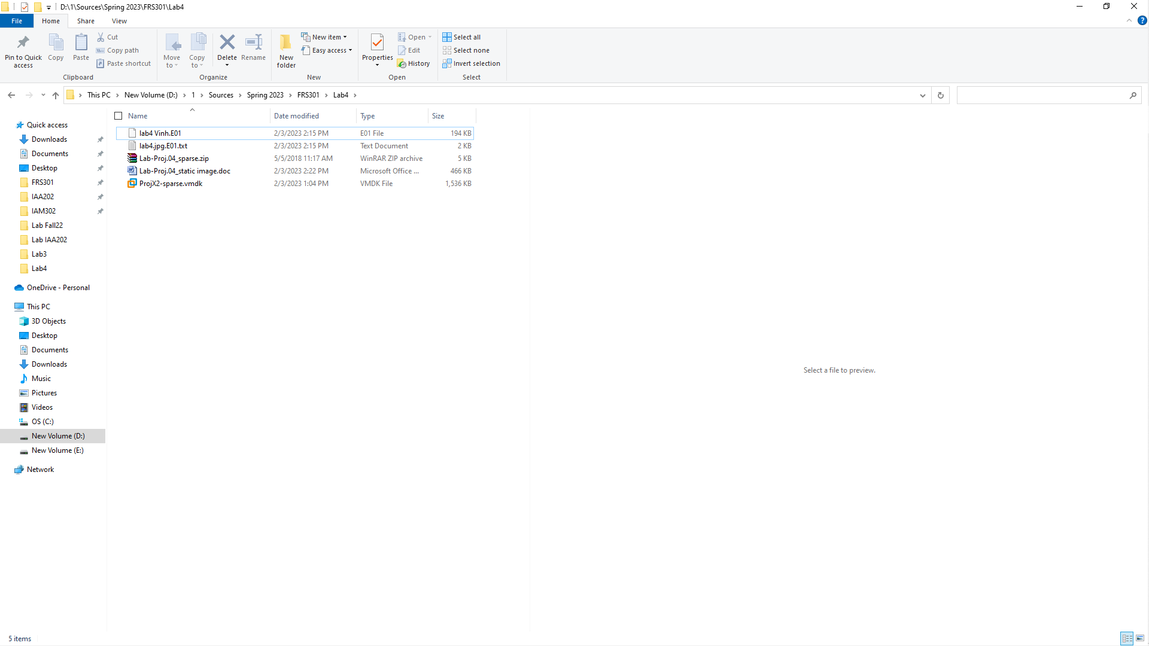

Turning in your Project
- Email the JPEG image to the instructor as an email attachment. Send it to: xxx@fe.edu.vn with a subject line of Lab-Proj 4 From Your Name, replacing Your Name with your own first and last name. Send a Cc to yourself.

